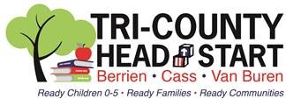

March 13, 2020

Dear Tri-County Head Start Families,
Due to the recent information from the State of Michigan and the Governor, we have made the difficult decision to close all of our classrooms and home visiting programs until Monday, April 13. Many of our classrooms reside in public schools; our independent sites are over 100 participants, receive food from public schools, or have staff who are impacted by the public school closures.
Your teachers and home visitors will contact you to deliver four weeks of home kits on either Monday or Tuesday. Additionally, your teacher and home visitor will contact you once per week to check in to see how your home kits are going, and to check in on your family. Your Family Advocate will also contact you at least twice during this closure to provide you with any resource information that you may need.
If you, or your family are experiencing COVID-19 symptoms please contact your local Health Department for further instructions.
We will keep you updated, through our Facebook page and Honeywell alerts, as we learn more information. We ask for your patience and understanding as we navigate this unique time.

Sincerely,
Chanda M. Hillman
CEO/Executive Director

